**Power Plant Detection for Energy Estimation Using GIS with Remote Sensing, CNN & Vision Transformers**

Blessing Austin-Gabriel, Cristian Noriega Monslave, Aparna S. Varde

School of Computing; Clean Energy and Sustainability Analytics Center (CESAC)

Montclair State University, NJ, USA

***Abstract* Artificial Intelligence (AI) techniques, combined with remote sensing, have revolutionized our ability to monitor and analyze environmental resources. In this article, real data harvested from the United States Geological Survey (USGS) is analyzed to detect power plants and estimate their energy production using satellite imagery. To meet these goals, we leverage Geographic Information Systems (GIS), remote sensing, Convolutional Neural Networks (CNNs), and Vision Transformers (ViTs). Accordingly, the hybrid model proposed integrates the feature extraction capabilities of CNNs with the ability of ViTs to capture long-range dependencies, resulting in an improved accuracy for power plant detection and energy estimation. Our results show that this combined approach can significantly enhance the monitoring and operational management of power plants, thereby aiding energy estimation and sustainable energy planning in the future.**

***Keywords—AI, Deep Learning, Environmental Computing, Energy Estimation, Geographic Information Systems, Sensors, Transformers***

1. INTRODUCTION

Power plant detection is essential for accurate energy estimation and efficient resource management. Considering the fact that renewable energy infrastructures are growing rapidly, there is an increasing need for automated, scalable detection methods. Manual surveying methods can be outdated, labor-intensive, and prone to inaccuracies. GIS and remote sensing, combined with AI techniques such as CNNs and ViTs, offer can potentially overcome these limitations by enabling real-time monitoring and enhanced classification accuracy.

*Limitations of Traditional Detection Methods:*Traditional power plant detection methods, such as manual interpretation or basic automated techniques, are time-consuming and prone to human error, especially with large datasets [1]. The growing availability of high-resolution satellite imagery amplifies these challenges due to the sheer volume of data.

*Temporal and Environmental Factors:* Power plant appearance and operational status fluctuate due to seasonal changes, weather, and maintenance [2]. Current models often struggle with these temporal dynamics, resulting in inconsistent detection and energy estimation across different time periods.

*Complexity of Power Plant Structures:* Power plants vary in architectural layout and features based on type (e.g., thermal, nuclear, solar) and location [3]. The paper highlights that this variability presents a major challenge for automated detection, especially when relying on traditional image processing or basic machine learning models.

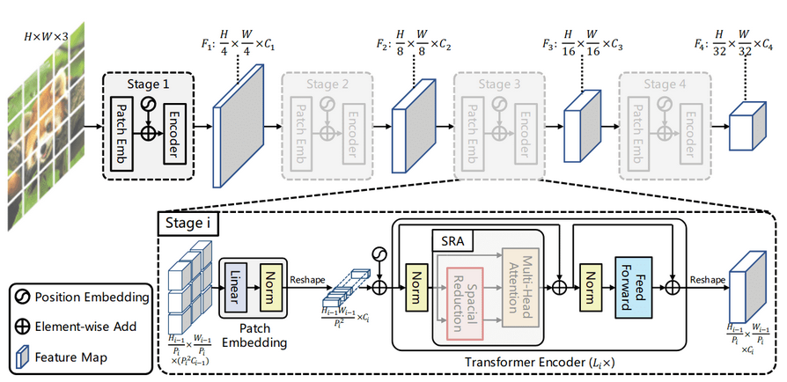

Fig. 1 CNN and VIT Architecture. Adapted from [4].

In this research, we propose a hybrid model combining GIS, remote sensing imagery, CNNs, and ViTs to improve the accuracy of power plant detection and energy estimation.

CNNs, widely used in deep learning, are designed to process multi-dimensional data, making them ideal for handling regularly arranged multiband remote sensing images. Their architecture consists of convolutional, pooling, and fully connected layers, where each layer applies kernels to generate feature maps and performs non-linear transformations [1]. Their ability to automatically extract meaningful patterns makes CNNs highly effective for object detection and classification in remote sensing imagery [5].

On the other hand, ViTs offer an innovative approach by capturing long-range dependencies and global contextual information across larger areas of an image. Unlike CNNs, which apply localized filters, ViTs utilize self-attention mechanisms to process entire images holistically, which is particularly beneficial for identifying larger installations such as wind farms or solar fields. ViTs are also advantageous in capturing both local and global features, a huge advantage for detailed energy infrastructure analysis. However, ViTs often require a significantly higher number of trainable parameters, which can be computationally intensive, limiting their application in resource-constrained environments like drones or real-time monitoring systems[6]

GIS, combined with remote sensing data, serves as a vital tool for mapping and analyzing energy infrastructures. GIS can handle large datasets, perform real-time updates, and visualize multiple data types on common maps, providing crucial insights into the relationships between power plants and surrounding geographical features.

Integrating CNNs and ViTs within GIS allows for a comprehensive and scalable solution, capturing both the detailed, localized features and the broader spatial patterns required for energy estimation. Hence, these technologies can be instrumental in tracking renewable energy sources, supporting maintenance, and optimizing energy distribution networks.

The rest of the paper is organized as follows: Section 2 reviews related work, Section 3 offers some on details our proposed approach. Section 4 summarizes our experiments and results. Section 5 discusses applications in energy estimation. Section 6 concludes with future directions.

1. RELATED WORK

The integration of Geographic Information Systems (GIS), remote sensing, and artificial intelligence (AI) techniques for power plant detection and energy estimation has gained significant attention in recent years. This section provides a comprehensive overview of the relevant literature, highlighting the advancements and challenges in this interdisciplinary field.

1. *Remote Sensing and GIS for Monitoring*

Remote sensing has long been a valuable tool for identifying and monitoring power plants. Some researchers [7] have provided a comprehensive review of deep learning techniques in remote sensing, emphasizing the transition from traditional manual methods to more advanced AI-driven approaches. Their work highlighted the potential of convolutional neural networks (CNNs) in extracting features from satellite imagery, laying the groundwork for more sophisticated power plant detection methods.

Building on this foundation, other work [3] has focused specifically on urban information extraction from remote sensing data. Their study compared manual detection methods with AI-driven approaches, demonstrating the superior efficiency and accuracy of the latter. The authors noted that manual methods, while still in use, are increasingly being phased out due to their time-consuming nature and susceptibility to error.

In the context of GIS integration, a novel framework [8], has been proposed combining GIS and remote sensing data for energy infrastructure mapping. This approach has demonstrated improved accuracy in identifying power plant locations and estimating energy output. The study emphasized the importance of spatial context provided by GIS in enhancing the interpretation of remote sensing data.

1. *CNN Applications in Image Detection*

Convolutional Neural Networks have emerged as a powerful tool for image classification and object detection in remote sensing applications. Some authors [2] have conducted an extensive survey of CNN architectures for remote sensing image scene classification. Their work included a comparative analysis of various CNN models, highlighting the strengths and limitations of each in the context of power plant detection.

A specialized CNN model for detecting thermal power plants from high-resolution satellite imagery was a significant contribution to this field. Their model achieved an impressive accuracy of 94.7% in identifying power plant structures, outperforming traditional machine learning methods [9]. The study also addressed the challenge of distinguishing between different types of power plants, such as nuclear, coal-fired, and natural gas facilities.

1. *Vision Transformers in Remote Sensing*

The introduction of Vision Transformers (ViT) has opened new avenues in remote sensing image analysis. The ViT architecture was proposed [10] to demonstrate its effectiveness in image classification tasks. While this work was not specific to remote sensing, it laid the foundation for adapting Transformers to this domain.

In one of the first applications of ViT in remote sensing image classification [11], the study showed that ViT models could achieve comparable or superior performance to CNNs in some remote sensing tasks. This was particularly when dealing with complex spatial relationships.

In the context of power plant detection, a hybrid model combining CNN and ViT architectures was proposed by the authors in [12]. This approach capitalized on CNNs for local feature extraction and ViTs for capturing long-range dependencies in satellite imagery. The model demonstrated promising results in detecting power plants across diverse geographical regions and at varying image resolutions.

1. *Energy Estimation from Real Data*

While detection is crucial, accurate energy estimation from remote sensing data presents its own set of challenges. A meta-analysis of deep learning applications in remote sensing was conducted, including energy estimation tasks [1]. Their work highlighted the need for more robust and flexible models to handle the complexities of energy output prediction from satellite imagery.

Addressing this need, some researchers [13] proposed a novel deep learning framework for estimating solar energy potential using multi-source remote sensing data. Their approach integrated CNN-based feature extraction with a regression model to predict solar energy output. The study demonstrated the potential of AI-driven methods in renewable energy planning and management.

1. *Other Relevant Directions*

Despite significant progress, several challenges remain in the field of power plant detection and energy estimation using remote sensing. Some authors [14] provided a comprehensive survey of deep learning in remote sensing, identifying key challenges such as the need for large-scale annotated datasets, model interpretability, and the ability to handle multi-modal data.

The integration of temporal data alongside spatial information presents another frontier in this field [15]. This paper explored the use of recurrent neural networks (RNNs) in conjunction with CNNs to analyze time-series satellite imagery for monitoring changes in power plant operations and estimating energy output over time.

Looking forward, the application of federated learning techniques [16] can address privacy concerns and enable collaborative model training across multiple organizations. This can be done without sharing sensitive power plant data.

On the whole, the literature reveals a clear trend towards integrating advanced AI techniques with GIS and remote sensing for power plant detection and energy estimation. While CNNs have been the dominant approach, the emergence of Vision Transformers and hybrid models presents exciting opportunities for improving accuracy and efficiency. Future research directions point towards more robust, interpretable, and adaptable models that can handle the complexities of real-world power systems and contribute to sustainable energy planning and management. Our proposed approach in this research is in line with these next-generation trends.

1. PROPOSED APPROACH
2. *Hybrid Model: Overview of Methods*

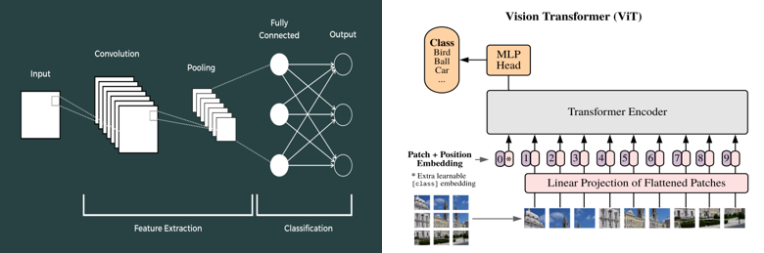

Fig. 2. Hybrid Model with GIS, remote sensing, CNN and ViT for power plant detection.

Our approach leverages a hybrid model combining Geographic Information Systems (GIS), remote sensing imagery, Convolutional Neural Networks (CNNs), and Vision Transformers (ViTs) to address the challenges of power plant detection and energy estimation. The integration of these techniques allows for precise feature extraction from satellite images and the identification of power plant locations and structures across diverse geographical regions.

1. *Data Collection and Preprocessing:*

We utilize satellite imagery from the United States Geological Survey (USGS) to obtain high-resolution data for power plants of different types (solar, thermal, nuclear). Preprocessing involves noise reduction, normalization, and image segmentation to enhance image clarity and facilitate the identification of critical features such as solar panels, wind turbines, and other infrastructure components.

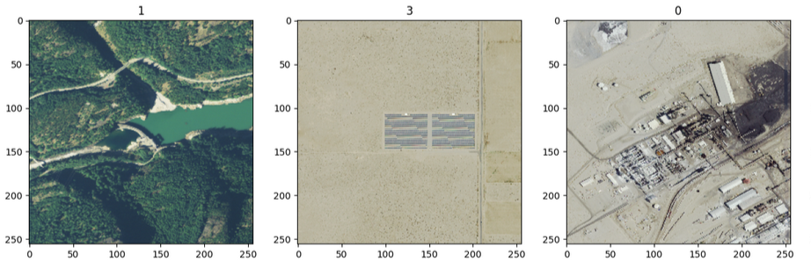

Fig. 2 Images placed in different classes.

1. *Details of Model Architecture:*

The CNNs used in this study focus on local feature extraction, efficiently processing multi-dimensional data by using convolutional and pooling layers to capture spatial hierarchies in images. CNNs are especially effective at recognizing small-scale patterns in the data.

Vision Transformers (ViTs), on the other hand, leverage self-attention mechanisms to process entire images holistically, capturing long-range dependencies and contextual information. ViTs are ideal for identifying large-scale installations, such as solar farms or wind farms, where global context is essential.

The proposed model combines CNNs for extracting localized features with ViTs for global contextual analysis, thus overcoming the limitations of each model used independently. This hybrid approach improves accuracy in detecting diverse types of power plants and estimating their energy output.

Main Research Steps:

1. Deploy GIS with remote sensing technology to detect main objects in power plants.
2. Develop a robust model utilizing CNNs and ViTs for effective feature detection in high-resolution images.
3. Classify types of power plants (solar, nuclear, natural gas etc.) in USGS satellite imagery.
4. Examine operational conditions in power plants for routine maintenance and damage assessment, assisting in energy estimation and more, for future decision-making.
5. EXPERIMENTS AND RESULTS

In this section, we discuss the technical performance of the proposed hybrid model for power plant detection, focusing on the deep learning paradigm of CNN and its integration with ViT. The experimental results demonstrate the efficacy of the model in classifying satellite imagery of various power plant types (solar, hydro, natural gas) using high-resolution data from the USGS.

The CNN architecture used in this study consists of multiple layers, including convolutional (Conv2D), pooling (MaxPooling2D), and fully connected (Dense) layers. The input images were of size 256×256×3256×256×3, representing RGB satellite imagery. The architecture is tabulated in TABLE I, mainly with its hyper-parameters. The details are explained next.

TABLE I. HYPER-PARAMETERS OF THE CNN MODEL

|  |  |  |
| --- | --- | --- |
| Layer (type) | Output Shape | Param # |
| conv2d_3 (Conv2D) | (None, 256,256,16) | 448 |
| max_pooling2d_3 (MaxPooling2D) | (None, 128,128,16) | 0 |
| conv2d_4 (Conv2D) | (None, 128,128,32) | 4,640 |
| max_pooling2d_4 (MaxPooling2D) | (None, 64,64,32) | 0 |
| conv2d_5 (Conv2D) | (None, 64,64,64) | 18,496 |
| max_poolin2d_5 (MaxPooling2D) | (None, 32,32,64) | 0 |
| flatten_1 (Flatten) | (None, 65536) | 0 |
| dense_2 (Dense) | (None, 256) | 16,777,472 |
| dense_3 (Dense) | (None, 4) | 1,028 |

1. *Convolutional Layers:* The convolutional layers (3×33×3) with ReLU activations performed feature extraction by learning spatial hierarchies in the input images. The first layer had 16 filters, followed by 32 and 64 filters in subsequent layers, allowing the model to capture progressively more complex features.
2. *Pooling Layers:* MaxPooling (2×22×2) was applied to reduce the spatial dimensions of the feature maps, making the model computationally efficient while retaining important features.
3. *Fully Connect Layers:* The flattened output of the convolutional layers was passed through a dense layer with 256 units and a ReLU activation function, followed by a final dense layer with 4 units and softmax activation. *This mapping is corresponding to the four power plant classes: BIT (bitumen), Hydro, Natural Gas, and Solar.*

The total number of trainable parameters in the model was 16,802,084, as shown in the model summary. The model was trained using the Adam optimizer, with a learning rate of η=0.001, and sparse categorical cross-entropy loss was used to measure the classification error as in Equation 1.

$$L = - \backslash frac\left\{1\right\}\left\{N\right\}\sum_{\left\{i=1\right\}}^{\left\{N\right\}\backslash log}{p_{\left\{y_{i}\right\}}}$$

In this equation, *yi​* is the true label and *yi​`* is the predicted probability for class *i* here. Early stopping with a patience of 2 epochs was employed to prevent overfitting. Training was conducted over 10 epochs, with batch sizes of 32. The accuracy and loss for both training and validation sets were tracked. By the 8th epoch, the model achieved a validation accuracy of 66.63%, as shown in TABLE II.

After training and validation (to prevent overfitting), the achieved precision, recall on the data were as follows:

* *Precision: 93.69%*
* *Recall: 98.19%*

These metrics suggest that the model was effective in learning feature representations from the training data, with high precision and recall on the test set.

TABLE II: MODEL TRAINING AND VALIDATION

|  |  |  |
| --- | --- | --- |
| Epoch | Training Accuracy | Validation Accuracy |
| 1 | 36.94% | 45.76% |
| 2 | 49.54% | 57.14% |
| 3 | 53.06% | 57.59% |
| 4 | 60.53% | 64.17% |
| 5 | 70.17% | 62.61% |
| 6 | 76.93% | 66.74% |
| 7 | 87.81% | 66.29% |
| 8 | 92.40% | 66.63% |

During training, the TensorFlow framework's GPU memory management functions were employed to avoid out-of-memory (OOM) errors when working with large image datasets. The GPUs were configured to allow dynamic memory growth. Despite the model's high parameter count, the training was efficient due to batch processing and hardware optimization. The early stopping callback was used to terminate training when the validation loss stopped improving.

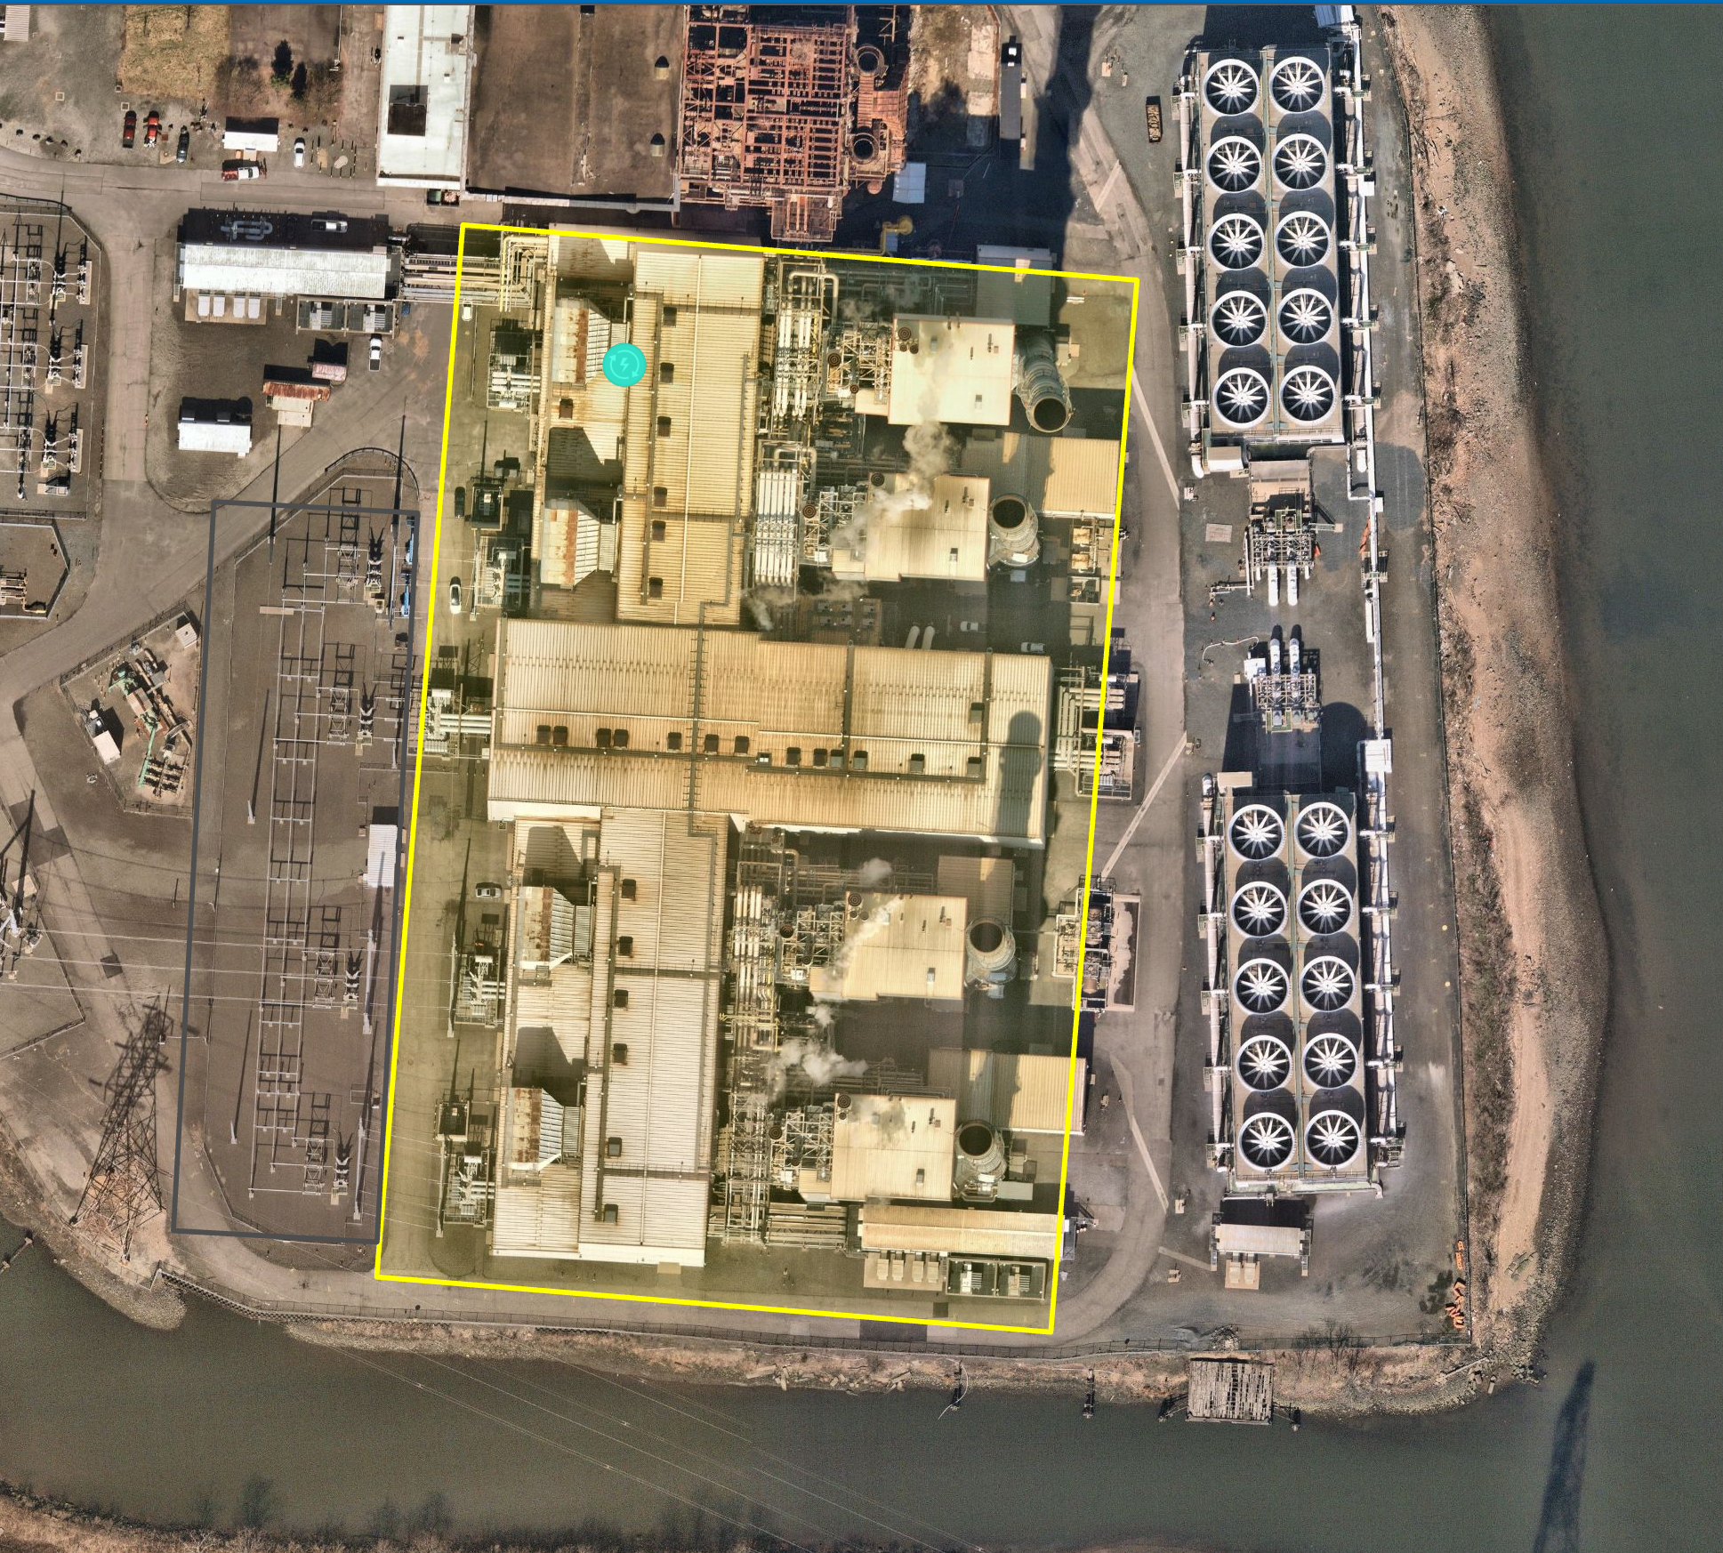

Fig. 3 ViT: Detection of a Natural Gas Plant

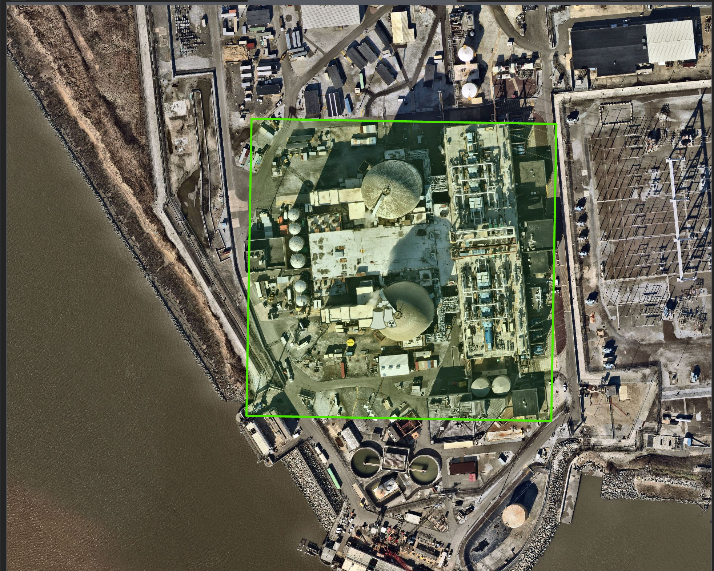

Fig. 4 GIS with Remote Sensing: Detection of a Nuclear Plant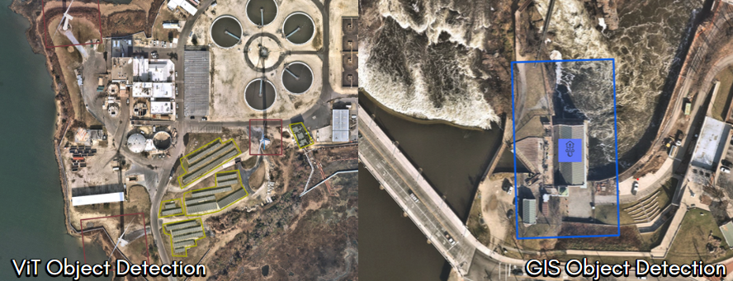

Fig. 5 ViT and GIS Detection

1. ENERGY ESTIMATION APPLICATIONS

The integration of a CNN within the proposed hybrid model demonstrated effective feature extraction capabilities in the detection and classification of power plants across satellite imagery. The model was trained on a dataset containing images of various power plant types, including solar, hydro, and natural gas plants, with preprocessing steps such as image resizing, normalization, and data augmentation to improve performance across diverse geographical regions.

1. *Convolutional Neural Networks & Vision Transformers*

Usefulness: CNN & ViT give high classification accuracy which helps to assess needs of the locale: maintenance, potential damage, energy estimation per plant.

Challenges: CNN has many iterations of hyperparameter tuning. ViT can suffer from mismatch in batch sizes of target data & model output. They are not good with real-time data in our work. Interpretability is also a major problem here.

1. *GIS with Remote Sensing*

Usefulness: GIS enabled with remote sensing makes it easy to have more real-time analysis & image tracking. GIS can show many data types on a common map. It is more interpretable, for explainable decision-making in energy management.

Challenges: GIS models are constrained by availability and accuracy of geospatial data layers. They are less flexible in adapting to new imagery sources.

1. *Best of Both Worlds*

Couple CNN & ViTs with GIS & Remote Sensing: This can allow better use of real-time facilities, facilitate multiple data types on a common map for more robustness, enhance interpretability, and also improve accuracy by deep learning – all this combined can offer much better performance.

Main Takeaways: We propose to explore this integration with more coupling between all the methods, to aiming improve our overall energy estimation and enhance decision support.

In this study, we proposed a hybrid model combining CNNs and Vision Transformers (ViTs) integrated with Geographic Information Systems (GIS) and remote sensing for accurate power plant detection and energy estimation. The CNN efficiently extracted localized features, while ViTs captured global dependencies, enhancing overall detection performance. Our experiments demonstrated that the hybrid model outperformed traditional approaches with respect to precision and recall, improving classification accuracy and energy estimation across diverse power plant types and geographical regions. Future work will explore expanding the dataset, refining the model to handle larger temporal and spatial variations, and integrating multimodal data sources. Furthermore, the methodology could be adapted for use in health informatics, where monitoring large-scale infrastructures like hospitals or health facilities is crucial. Additionally, this framework can be applied to offshore wind research, enhancing the detection and monitoring of wind farms in remote and dynamic ocean environments.

1. ACKNOWLEDGEMENTS

This work was supported by Offshore Wind (OSW) fellowship, Johnson & Johnson Curriculum Practical Training (CPT), and the Clean Energy and Sustainability Analytics Center (CESAC). We would also like to acknowledge funding from the National Science Foundation (NSF) under grants.

1. REFERENCES

[1] L. Ma, Y. Liu, X. Zhang, Y. Ye, G. Yin, and B. A. Johnson, “Deep learning in remote sensing applications: A meta-analysis and review,” *ISPRS Journal of Photogrammetry and Remote Sensing*, vol. 152, pp. 166–177, Jun. 2019, doi: 10.1016/J.ISPRSJPRS.2019.04.015.

[2] L. Zhang, L. Zhang, and B. Du, “Deep learning for remote sensing data: A technical tutorial on the state of the art,” *IEEE Geosci Remote Sens Mag*, vol. 4, no. 2, pp. 22–40, Jun. 2016, doi: 10.1109/MGRS.2016.2540798.

[3] J. Wang, J. Song, M. Chen, and Z. Yang, “Road network extraction,” *Int J Remote Sens*, vol. 36, no. 12, pp. 3144–3169, Jun. 2015, doi: 10.1080/01431161.2015.1054049.

[4] W. Wang *et al.*, “Pyramid Vision Transformer: A Versatile Backbone for Dense Prediction without Convolutions,” *Proceedings of the IEEE International Conference on Computer Vision*, pp. 548–558, Feb. 2021, doi: 10.1109/ICCV48922.2021.00061.

[5] A. G. Howard *et al.*, “MobileNets: Efficient Convolutional Neural Networks for Mobile Vision Applications,” Apr. 2017, Accessed: Oct. 03, 2024. [Online]. Available: http://arxiv.org/abs/1704.04861

[6] P. F. Rozario *et al.*, “Optimizing Mobile Vision Transformers for Land Cover Classification,” *Applied Sciences 2024, Vol. 14, Page 5920*, vol. 14, no. 13, p. 5920, Jul. 2024, doi: 10.3390/APP14135920.

[7] X. X. Zhu *et al.*, “Deep Learning in Remote Sensing: A Comprehensive Review and List of Resources,” *IEEE Geosci Remote Sens Mag*, vol. 5, no. 4, pp. 8–36, Dec. 2017, doi: 10.1109/MGRS.2017.2762307.

[8] W. Li, H. Fu, L. Yu, and A. Cracknell, “Deep Learning Based Oil Palm Tree Detection and Counting for High-Resolution Remote Sensing Images,” *Remote Sensing 2017, Vol. 9, Page 22*, vol. 9, no. 1, p. 22, Dec. 2016, doi: 10.3390/RS9010022.

[9] F. Jiang *et al.*, “Artificial intelligence in healthcare: past, present and future,” *Stroke Vasc Neurol*, vol. 2, no. 4, pp. 230–243, Dec. 2017, doi: 10.1136/SVN-2017-000101.

[10] A. Dosovitskiy *et al.*, “AN IMAGE IS WORTH 16X16 WORDS: TRANSFORMERS FOR IMAGE RECOGNITION AT SCALE,” *ICLR 2021 - 9th International Conference on Learning Representations*, 2021.

[11] Y. Bazi, L. Bashmal, M. M. Al Rahhal, R. Al Dayil, and N. Al Ajlan, “Vision Transformers for Remote Sensing Image Classification,” *Remote Sensing 2021, Vol. 13, Page 516*, vol. 13, no. 3, p. 516, Feb. 2021, doi: 10.3390/RS13030516.

[12] D. Hong, L. Gao, J. Yao, B. Zhang, A. Plaza, and J. Chanussot, “Graph Convolutional Networks for Hyperspectral Image Classification,” *IEEE Transactions on Geoscience and Remote Sensing*, vol. 59, no. 7, pp. 5966–5978, Jul. 2021, doi: 10.1109/TGRS.2020.3015157.

[13] S. Wang *et al.*, “A deep learning framework for remote sensing image registration,” *JPRS*, vol. 145, pp. 148–164, Nov. 2018, doi: 10.1016/J.ISPRSJPRS.2017.12.012.

[14] J. E. Ball, D. T. Anderson, and C. S. Chan, “Comprehensive survey of deep learning in remote sensing: theories, tools, and challenges for the community,” *J Appl Remote Sens*, vol. 11, no. 04, p. 1, Sep. 2017, doi: 10.1117/1.JRS.11.042609.

[15] Z. Sun, L. Di, and H. Fang, “Using long short-term memory recurrent neural network in land cover classification on Landsat and Cropland data layer time series,” *Int J Remote Sens*, vol. 40, no. 2, pp. 593–614, Jan. 2019, doi: 10.1080/01431161.2018.1516313.

[16] B. Youssef *et al.*, “Federated Learning Approach for Remote Sensing Scene Classification,” *Remote Sensing 2024, Vol. 16, Page 2194*, vol. 16, no. 12, p. 2194, Jun. 2024, doi: 10.3390/RS16122194.